Red Devils Hub – Midterm Project
ITC4214A1 - INTERNET PROGRAMMING - SPRING SEMESTER 2026
Prof. Dr Leonardos Mageiros
Andrej Angjushev – 277944
02/03/2026

Part 1 – Description of Website

Red Devils Hub is a dedicated Manchester United fan blog which focuses on everything that correlates with the football club. From the latest match score to the newest transfer rumor, the Red Devils Hub offers many functionalities. The home/index page consists of a hero image (Old Taraford- Manchester United’s home stadium) with a short introduction. There are three main sections in the home page:
- Latest Match: Carousel that showcases the latest matches by Important moments, description for each image and a “view player ratings” button that takes the user to the match rating page.
- Explore More: 3 mini cars that gives short description of the other pages as well as navigation buttons.
- An API of the 2026 Premier League Table with live updates.

The Match Rating page allows the user to express their feelings about the game through the player rating system. To be specific, the page contains one big section where the players who played the latest games are represented with a card each. The user can rate the player from 1 (poor) to 10 (excellent) and choose their MOTM (Man of the Match) by giving a star to one player only. Once the user is done with their ratings, they can submit them and based on the selected data a bar chart is generated. It shows the number of players who have received a specific player rating. Additionally, the stats section calculates the average player rating and displays the users MOTM. In case the user is not happy with their ratings there is a reset button where the user can rate the players again.

The Transfer page allows the user to scroll through already existing transfer rumors or add their own transfer rumor. To be specific, besides the carousel section which shows the creator’s favorite rumors there is also a form where the user can add their personal favorite. The form consists of fields like “Name”,” Price”, “Position” and etc.… Each of the fields has an input validation as well as star next to the title of the field which indicates that this information must be field in. In case there is an insufficient input and error message shows up. Once the user adds the transfer, they have the option to either delete or edit the transfer. The transfers once added are also persisted, meaning once the page is refreshed they are not deleted and saved in local storage.

The Contact page is consisted out of a contact a form where the user can send a question regarding the website. The contact form has input validation as well as word limitation of around 200 words to stop unserious users from writing endless messages. Once the users fills out each filed correctly a confirmation message appears to confirm this action. Additionally, there are cards of contact information, social media links as well as google map’s locations.
The About is a simple page that shares the story and the ambitions of the website. To be specific it consists out of few mini card sections that showcase the functionality of the website as well as the team members. Additionally, there is a testimonial carousel that showcases user feedback.
All the pages consist of an identical header and a footer. The header consists of the website logo, a highlighted navigation bar (based on which page the user is on) and dark/light mode button. Additionally, the navigation bar turns into a hamburger menu if it is displayed on smaller screens. Likew ise the footer is identical on all pages, with the additional functionality of social media links.

Part 2 – Important Coding Decision

The header was implemented using Bootstrap’s responsive navbar to ensure responsiveness, and accessibility. The “navbar-expand-lg” tag was chosen to optimize usability across desktop and mobile devices. A “hamburger” structure was implemented using Bootstrap’s collapse system, which ultimately reduces the need for custom JavaScript code. The dark mode toggle was integrated as a separate element to enhance user experience.
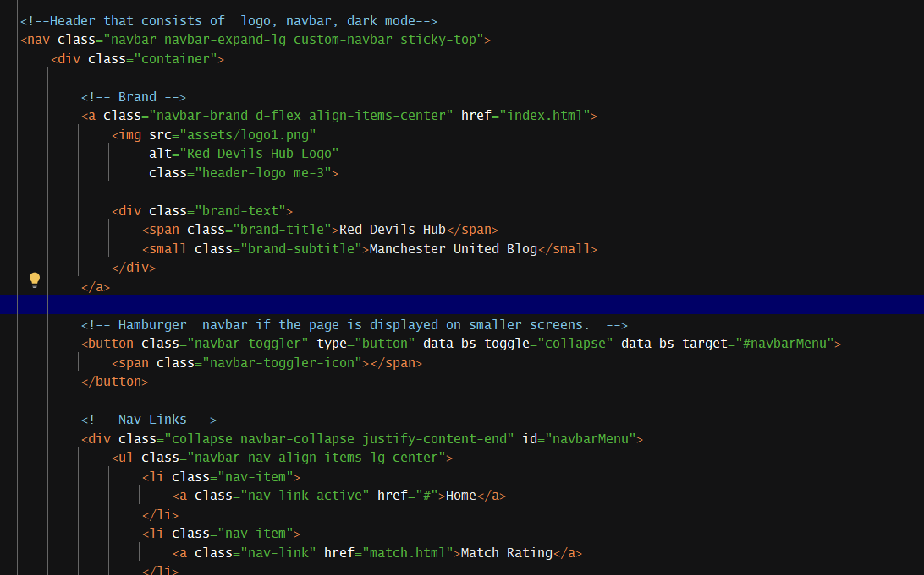
Picture 1 – Header

I decided to use a live Premier League table for my API. As this was harder functionality to add I used appropriated documentation from the API creators as well as help from AI to modify more challenging parts of the JavaScript code. To be specific, The Premier League table was implemented using a dynamic API fetch approach to ensure real-time data functionality. A loading state was implemented to improve the functionality of the table. Programming techniques such as null checks and data sanitization were applied to prevent runtime errors. The data is transformed and enhanced through a custom algorithm that approximates recent form using win/draw/loss ratios. Error handling ensures graceful degradation in case of network or API failure. - Main source used for API implemntation
The player rating system creates the rating buttons using JavaScript instead of writing them manually in the HTML. This helps reduce repeated code. Click events are handled in one place, which allows the program to manage all rating and star buttons efficiently. Only one rating can be selected per player, and only one player can be chosen as “Man of the Match” at a time. When the user submits ratings, the program collects all selected values and calculates the average score and how many times each number (1–10) was chosen. The results are then displayed in a bar chart using Chart.js. The chart automatically adjusts to light or dark mode and updates each time new ratings are submitted. - Main Source Used for bar chart.
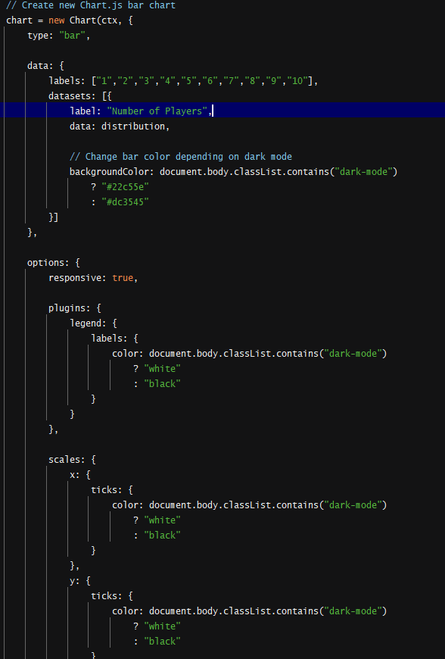
Picture 2 – Pie chart with Chart.js

The transfer system stores all rumours inside a JavaScript array. The table is created automatically from this array, so the content updates whenever the data changes. LocalStorage is used to save the transfer data in the browser. This means that when the user refreshes the page, the added rumours are still there. The edit function works by keeping track of which row is being edited. Only one row can be edited at a time. When the user saves the changes, the data is updated, saved again to Local Storage, and the table is refreshed. Filtering and sorting work by creating a temporary copy of the daThis keeps everything organised and prevents errors. Overall, the table always shows the latest data because the page is updated every time the data changes. - Source used for local storage

The contact form uses JavaScript to check that all user inputs are correct before allowing submission. It includes a live word counter that limits the message field to 200 words, updating in real time as the user types and turning red if the limit is exceeded. The script validates that the name and subject are at least three characters long, the email follows a proper format, and the message contains at least ten characters but does not go over the word limit. If any input is invalid, the form highlights the field and prevents submission. When all inputs are valid, the information is displayed in a confirmation message, and the form is then reset along with the word counter.
The footer is generated using JavaScript after the page finishes loading, which is handled by the DOMContentLoaded function. Instead of writing the footer HTML manually in every page, the footer content is stored inside a JavaScript template and inserted into a placeholder <div id="footer"></div> using innerHTML. This reduces code repetition because the footer only needs to be written once in the footer.js file. If any changes are needed, they can be made in the main JS file and will automatically update across all pages.

Part 3 – Chrome Lighthouse analytics
Performance – 82
The performance score of 82 shows that the website loads quickly and is technically efficient. Key metrics such as First Contentful Paint and Total Blocking Time are strong, meaning the page appears fast and JavaScript does not delay rendering. The main area for improvement is Largest Contentful Paint, likely caused by large hero images. Optimising image sizes and formats would help further improve performance.
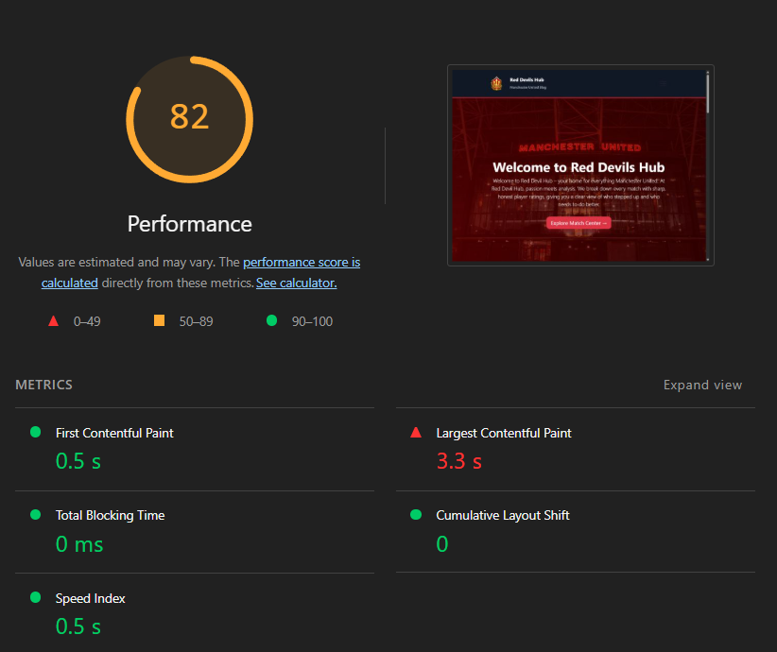
Accessibility – 72
The accessibility score of 72 indicates that the website has some issues that may affect users who rely on assistive technologies such as screen readers. The main problems relate to buttons and links that do not have accessible/descriptive tags.

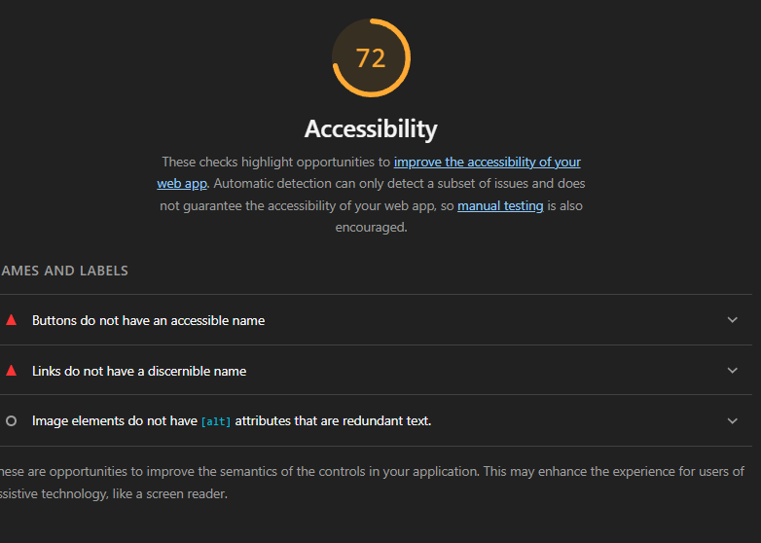

Best Practices – 100
A score of 100 in Best Practices demonstrates that the website follows development standards and security guidelines. There are no major issues related to deprecated APIs, browser errors, or security vulnerabilities.

SEO – 82
The SEO score of 82 suggests that the website is mostly optimised for search engines but still has some improvements to make. The main issue is the absence of a meta description and some links lacking descriptive text.
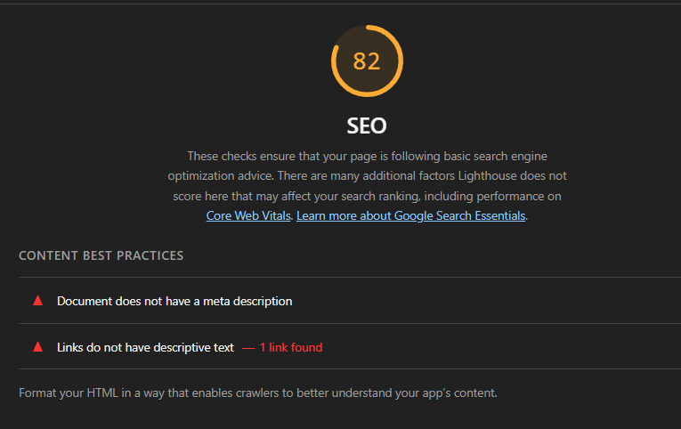

Part 4- Evaluation & Self Reflection

The overall process of the project was straightforward and not extremely challenging. To be concise, before the start of the project I set certain deadlines which I mostly managed to complete in time. Consequently, I was not rushing few days before the deadline to finish my pages but rather trying to fix & upgrade some smaller problems. However, one of my main challenges was the use of IntelliJ as my IDE. Specifically, IntelliJ has its own preview system which is different from the VS code live server for viewing my website. This meant that I had to reconstruct my project and some of my code which was a bit frustrating. Additionally, this project also reassured me the importance of version control & GitHub. With a bigger project not, every change can be reversed with a simple “ctrl + z”, hence why I realized that frequent git pushes are quintessential.

GitHub link: https://github.com/Gjushee/Internet-Programming---Coursework-

Sources Used:

https://developer.mozilla.org/en-US/docs/Web/API/Window/localStorage

https://www.chartjs.org/docs/latest/charts/bar.html.

https://developer.mozilla.org/enUS/docs/Web/API/Fetch_API/Using_Fetch

https://www.chartjs.org/docs/latest/charts/bar.html.

https://prismic.io/blog/css-hover-effects

https://www.freecodecamp.org/news/javascript-dom-manipulation/

https://www.w3schools.com/js/js_htmldom.asp

https://developer.mozilla.org/en-US/docs/Web/API/Window/localStorage

